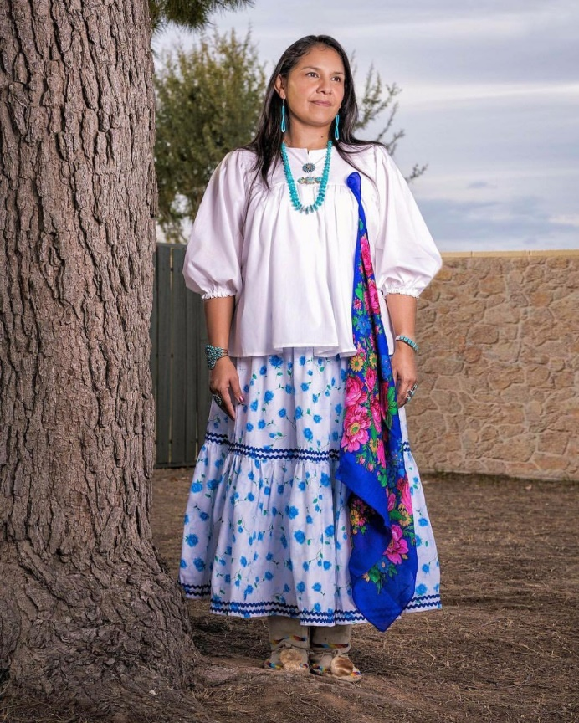



UNDERSTANDING FUEL FOR THE BODY PART 1, 2 and 3

Learn how to nourish and maximize fuel for the body!

#### All 3 events will be held at the Tunli Community Center from 11am to 1pm and will include Lunch.

**Part 1:** 8/27/19 Understanding Fuel For The Body

**Part 2:** 9/24/19 Gut Health and Optimizing our Fuel Source From Nutrition

#### Part 3: 10/22/19 Planning and Goal Setting

*Dawn Manuelito is a Health and Wellness Coach who helps people*

*Build and live healthier lifestyles.*

* ***Dawn has 9* years *in education experience within the health and wellness industry . She is currently studying at Arizona State University for her BA in Interdisciplinary Studies with concentrations of Exercise Wellness/Healthy Living and Nutrition. She received her AAS in Exercise Science and Certificate in Strength, Nutrition & Personal Training from Chandler-Gilbert Community College . Dawn has worked with a diverse population to include special health risk populations.***